Software engineering for big data analaysis

CSA-1035

EXP NO: 25

1. Draw a Class diagram for a Restaurant Systems. The activities of the Restaurant system are listed below. Receive the Customer food orders, Produce the customer ordered foods, Serve the customer with their ordered foods, collect payment from Customers, Store customer payment details, Order Raw Materials for food products, Pay for Raw Materials and Pay for Labour.

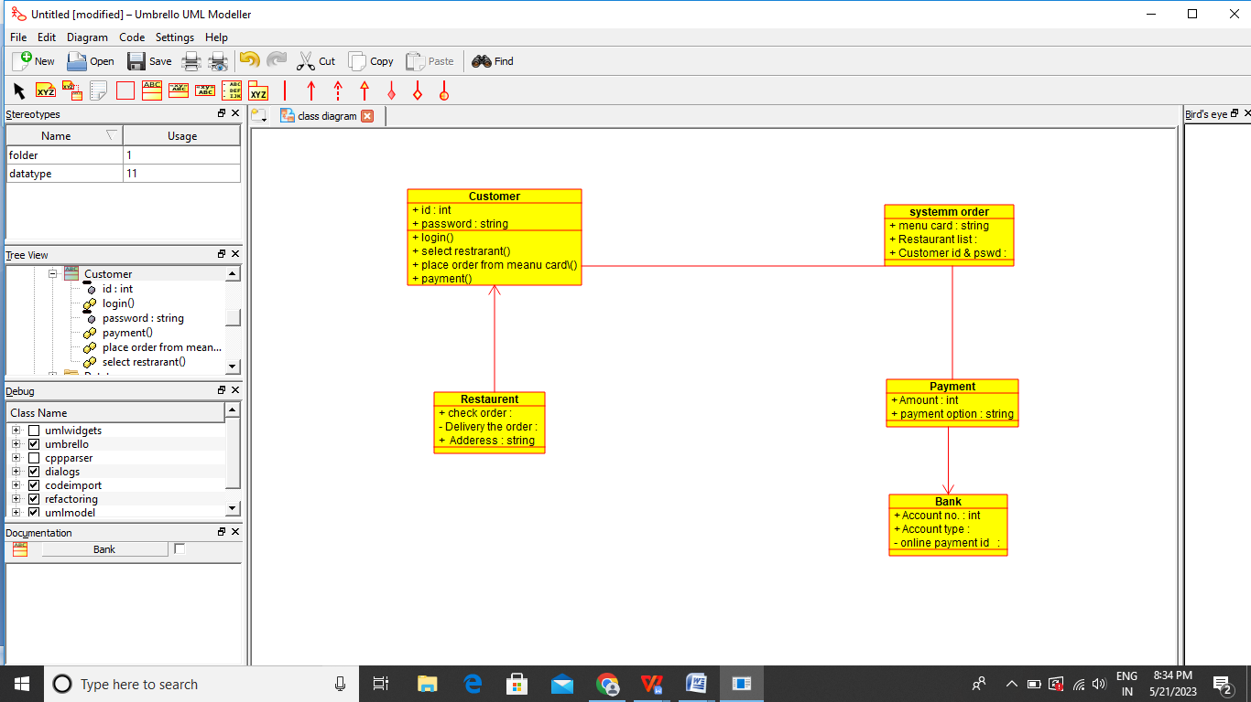

Result:-

Thus the use class daigram for restrarent is drawn and verified successfully